**Town of Summerhill**

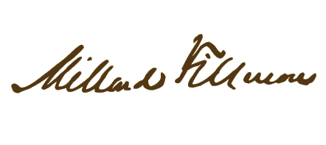

**Scholarship Application**

**Student’s Name:**

**Address:** **City:** **Zip:**

**Phone:** **Date**: **Sex:**

**Honor Roll Student?** **Yes** **No**

**School:**

**Summarize all community volunteer activities involved in:** *(if additional space is needed, continue on the backside of this application. Indicate also if paid or a volunteer.):*

**References:** *(please provide references that are not family members or friends for the Scholarship Committee Chairman to contact.) Please submit a letter from each person.*

**(1):** **Phone Number:**

**(2):** **Phone Number:**

**(3**):___________________________________________________________________ **Phone Number** :________________________________

**College Student plans to attend:** *(Provide copy of acceptance letter)*

**Field of Study majoring in:**

**Note:** The amount of the scholarship may vary; however, it will never be less than $250.00 *(Two Hundred and Fifty Dollars).* The winner(s) will be notified by letter.

**Return applications by May 1, 2025 to: Town of Summerhill**

**13606 Route 90**

**Locke, NY 13092**

**For further information, contact Summerhill Town Clerk at (315) 497-3494**